Court Rye & David Scully
Microsoft + CU Future Potential in Information Technology

Problem/Situation Description: As a result of growth in the technology job market, Microsoft, Match.com, and GMAC (among others) have recognized a deficit between their needs and the current supply of qualified IT/business systems employees. Demand is outpacing graduation rates, while IT enrollment is slipping due to negative perceptions from outsourcing and the dot-com crash. This dilemma was the inspiration for the Future Potential in Information Technology career event.

The FPIT career event was designed as a way of providing students with information about job opportunities and to raise awareness of university course offerings in the fields of information technology.

Marketing Objective: Gain 100+ qualified attendees.

Target Audience: Freshman and sophomore business and ATLAS (Alliance for Techonlogy, Learning, and Society) students currently attending the University of Colorado at Boulder.

Budget: The team received $200 for its marketing activities. The event location was pre-determined and paid for by a group of sponsors – the University of Colorado, Microsoft, and Match.com.

Strategy: Use an integrated approach to create a recognizable event “brand” image building retention and follow up action from students. Create repeated exposure through the use of multiple channels of communication, word of mouth, buzz, and online tools. Minimize cost while maximizing communications to targeted students.

By thinking and acting creatively, and performing at a rapid pace, our team was able to minimize cost while overshooting our objective by 30%. The utilization of additional sponsors, consistency of marketing communications, and technology enhancing processes and tools made the marketing side of the event a wild success. The event was so successful our team was requested to document our processes and strategies for use with universities nationwide.

Results: 230 registered students, 140 student attendees.

Future Potential in IT, Academic Program
University of Colorado at Boulder
Folsom Field Stadium
February 7, 2006
6pm – 9pm

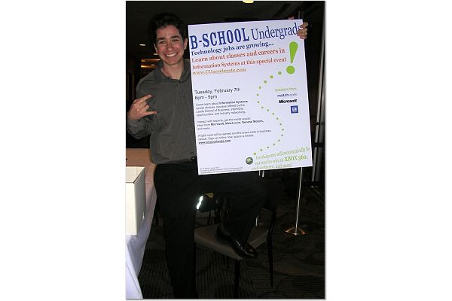
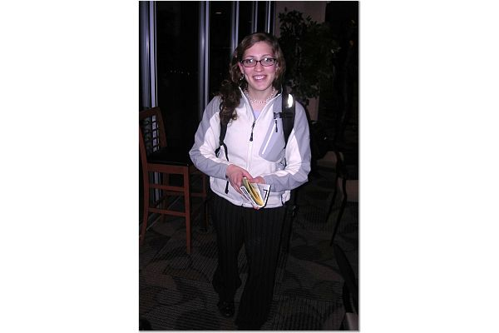
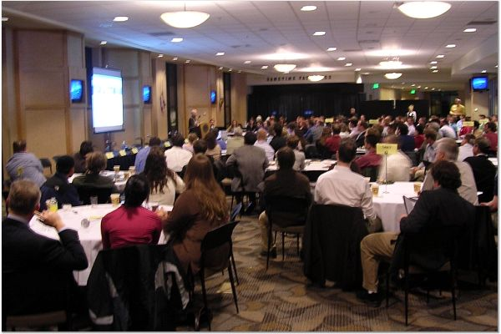
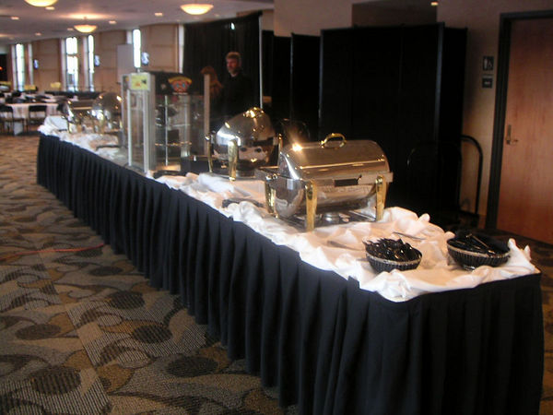
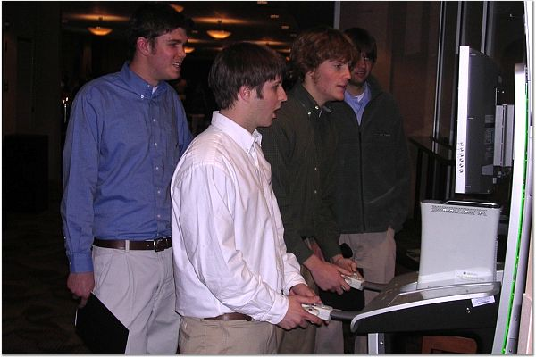
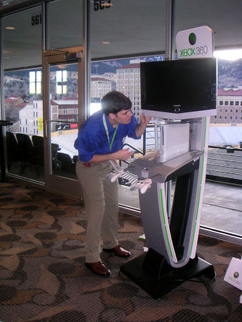
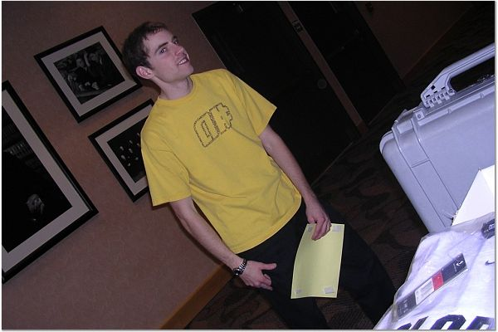

Attendance  Target Audience: Undecided students, students in other majors looking at minor/dual major options. | Total Attendance well over 200  237 students registered with 122 confirmed as attending but many students skipped the in person check-in due to lines and went straight into the session.  ~ 40 business people and faculty in attendance.  The room was set up for 200+ and all seats were taken with some people standing.
Reach/promotion | Estimated total: 2,000  Promotions were broad:  - Posters  - Xbox 360 demo  - E-mails  - Class announcements
Partner participation | Confidential
Faculty participation | Confidential
Student Support | Court Rye, David Scully, Jason Latimer, and Aaran Secor went well above and beyond the call of duty to make this event a success. They spent their own money and utilized personal contacts to acquire an Xbox 360 with the intent of promoting the event and Microsoft. Court was the primary student interface and all the students spent enormous amounts of their personal time during the weeks leading up to the event to help make it the successful, great event that it was!
Speakers | MC and Panel Moderator: Jim Marlatt, CU Leeds School of Business  Kickoff Presentation: Coach Hawkins CU Football Coach  Keynote speakers:  1) Eddie Dombrower Sr. VP new Product development Match.com  2) Lucy Sanders, CEO National Center for Women and Technology and Bell Labs Fellow  3) Chris Lapsing CIO GMAC Commercial Holding Capital Corp
Panel participants | Scott Johnson, Regional Technical Officer, Microsoft  Ridawn Cummings, Applications Manager Leeds School of Business  Kate Dueber, Systems Student  Tyler Ecoffy, Sun Microsystems  Janis Fairchild, CEO Data USA  Kevin Kapich, Systems and Telecommunications Student  Chris Kulish, Partner Holland and Hart  Ramiro Montealegra, Professor Leeds School of Business  Rob Richarson, Software Engineer, Level 2 Communications  Zoya Voronovich, Data Mining Engineer, AnswerOn
Press | A Press release – Appendix B – was dispatched to the wire service.  The broadcast coverage – which aired on KCNC-TV (CBS affiliate) to an estimated audience of nearly 35,000  Print Coverage –  Boulder Daily Camera – circulation of 33,000, widely read by many influential business, educational and political leaders in the area.  Colorado Daily News  See Appendix B for details

The highlight of the Boulder Seminar was the outstanding student involvement, enthusiasm, great attendance and press coverage. The average student ratings were 6.25 out of a possible 7 for males and 6.3 out of 7 for females. Of 48 overall surveys completed, 17 indicated they were likely or very likely to change majors. This is response from nearly 40% of the attendees. Of the women, 10 total respondents, 5 indicated they were likely or very likely to change their major or 50% of the women responding.

The program agenda was designed to get IT experts in front of the audience and relate their experiences in their roles in IT, what they do for a living and articulate the very wide range of opportunities available in the world of IT. Handouts were provided for 13 different speakers or panelists working in IT, including their education background, job experience and what they love about IT.

There was fabulous student participation in organizing and promoting the event. The enthusiasm shown by the team of students and faculty was energizing and gave the session a real boost. The business people who attended were energized by the student’s excitement and earnest desire to learn more about the field.

A common theme in the student survey and verbal comments provided to the CU host, Jim Marlatt, was that the session provoked reflection and prompted the students to reconsider what they are studying at CU, and giving consideration to IT as a major.

Overall I would report that the seminar was a success. The event was very well attended by students and they were enthusiastic about the speakers and career opportunities. The time slot worked very well and presented no conflict with class schedules so students could stay for the whole event. The venue in the club level of the football stadium was very nice with tables set up for small group interaction while they ate. The food that was provided was well below expectations for the price and unfortunately, desserts ran out quickly.

There were a lot of positive interactions at the tables between local business people, IT professionals, speakers, faculty, and invited experts which was very much appreciated by all involved parties. There was lively conversation and students appreciated the intimate interaction and ability to ask questions 1:1.

In the negative column we had too many presenters, some were quite long-winded leaving little time for the panel discussion. With a wealth of panel members we were able to offer a number of different viewpoints, but the impact was diminished by the limited time each panel member had to make their point.

Key “Learnings”

- Be more prescriptive with the speakers as to the topic they are being asked to present and strict time limits
  - Dispelling the myths presentation can be given to guest speaker to present
  - Future IT skills presentation based on research information from the SIM study can be developed into a standard presentation that could be given to a guest speaker to present.
  - Economic justification for IT jobs and the impact on wealth creation or contribution to society
- Not more than 3 main speakers and preserve the time for Q&A with the panel, or 1:1 interactions.
- Provide a list of future jobs and what skills are needed for them. This should highlight opportunities for women and minorities. If covered in a presentation whitepapers or articles to back up the presentation would be good handouts to give depth on the subject.
- How a degree in IT along with internships and on the job experience differentiates a student from the pack (this needs to be more in your face rather than the soft sell)
- Engage earlier with the career counselors and other departments to draw more non-IT students.

Event Promotion
All event promotion and marketing at CU was done by the student volunteers listed at the start of this report.

The marketing efforts were a huge team effort and showed real innovation and creativity. I would like to point out the initiative taken by this outstanding group of students and their enthusiasm in evangelizing this program to their peers.

The Facebook was executed by Jason Latimer
Posters, flyers, and in class announcements created by Court Rye, executed by all
Card swipe, name tags, tracking system, surveys, and post-event tabulations created and executed by David Scully
Reminders by David Scully, Aaran Secor and Jason Latimer
Xbox promo tables, sponsor loop, megatron video, and game giveaways at the event by Court Rye with support from GameStop.

Here is a brief review of their contributions as communicated by Court Rye:

Posters came in five flavors:

- Color fliers: 100 total (in and around the B-school ~15) (in and around other major auditoriums on campus ~25) (in and around the residence halls ~60)
- Black and white mini-flier half sheets: 250 total (these were handed out mostly at our Xbox 360 table ~60% but small stacks were left at the career center in the business school and the campus wide career center as well as the diversity office in the Leeds school of business ~40%)
- There may have been more fliers for the ATLAS program but we didn't see many results and one ATLAS student who attended said he hadn't seen any posted. I think we provided them with ~50 total to post.
- Direction "arrow" sheets: ~40 total (these were done in color and were posted in and around the stadium the evening of the event)
- Large poster board banners: 2 total (one of these was positioned in the UMC entrance and the other was placed in the entrance walkway to the Leeds school of business, the Leeds one was also posted next to our Xbox 360 table during the promotion)
- Overhead transparencies: ~5 (these were used in conjunction with announcements to large business classes, announcements were made in Math 100, Duane Physics, and a few others, jim should have more details for this)

I think it is worth noting that our website, fliers, posters, and direction arrows all had common colors and theming. When developing these advertisements my goal was to create a fully integrated marketing communication. We used the Xbox green to capture interest about the 360 giveaway and other bright colors set us apart from general fliers around campus, I like the way you kept that color scheme for your new logo Betsy!

It is also worth noting that we registered a new domain "www.cuaccelerate.com" it was set up to forward to the URL on the Leeds website to make it easier for people to remember and find (and easier to fit on our fliers).

Announcements were made in many classes, mostly by Jim because he teaches them, but our team also helped make a few announcement in Math 100 as well as Duane Physics buildings for business related subjects (B-Law and Technology in Society).

The Xbox 360 demo was prepared twice. It was done during the week leading up to the event and it was held in the entrance walkway "lobby" area of the Leeds school of business. We used one long fold up table with four or five chairs, my monitor and speakers, and an Xbox 360 unit that I purchased for the event (afterwards I sold the 360 to a good friend of mine at Hewlett Packard to recoup the investment). I would estimate that over 300 people saw the demo over the course of the two day setup (this is very rough) but only ~15% actually stopped to chat or play games. ~50% took our black and white info slips.

Emails were sent out in a few different ways

- Each of our 4 team members invited ~400 students to join the "FPIT facebook group" (I think nearly 200 registered, that's ~13%)
- Jim sent out emails to his faculty friends and people who he thought could help recruit, I sent an email to the diversity office at the Leeds school of business and they actually did a small announcement at one of their meetings and gave out ~30 of our black and white mini-fliers.
- A follow-up round of emails was sent out to those who had registered for the event the day before it happened
- Career services included a bullet about our event in their weekly student notice email
- A local news channel (news 4) ran a quick mention of our event on the evening broadcast
- A local newspaper did an article of the event but I am having trouble locating it... I believe it was done before the event happened

I have listed most of our quantifiable efforts above, along with those events and promotions I spend a lot of time announcing the FPIT event to my residents at floor meetings and during our staff meeting. I tried to generate word of mouth interest in the event on my own time and I think that made a small difference in spreading the word.

Kick-off presentation
The CU football coach Hawkins appropriately kicked off the session and teed up the question of the evening, “What do you want to be” and “What would you do for free?” He was challenging and motivational.

Keynote presentation
Coach Hawkins was followed by Eddie Dombrower, senior Vice President New Product Development at Match.com who though interesting at the start, took much more than his allotted time and rambled. He did not address the future skills needed in IT nor how the students should get prepared for the new jobs opening up. As a result, the rest of the evening ran late and the panel discussion needed to be cut short.

Lucy Sanders, CEO for the National Center for Women and Technology gave an excellent presentation and “show and tell” using a cell phone and the I-Robot vacuum cleaner getting students to participate with ideas of what new kinds of technology could enable people to live, work, and play better.

Chris Laping, CIO of GMAC talked about how to set goals for a career and the 12, 24 and 36 month plans for success. He gave tips for success and how to make an impact. He addressed soft skills needed in IT and talked about leadership.

Panel Discussion
The panel discussion was lively and the students were very engaged. However, due to time constraints the discussion needed to be cut short. But after the session a good number of students stayed to continue the conversation and ask more questions.

The session ended with the prize drawing for game software donated by a local gaming store and the Xbox 360.

Attendance
An on-line registration site was created and went live 2.5 weeks before the night of the event. The average number of registrants per day was 10 with a “procrastinator’s” spike of more than 40 in the last 24 hours before the seminar.

Q&A
The students were a bit shy at the beginning of the Q&A, but with some prompting from the emcee they began asking a wide range of questions. Most of the questions asked were right on target with the goals of the presentation.

Student Questions

The information below was collected from our students as they registered for the Future Potential in IT event. This is intended to help you understand the kinds of information they would like to learn more about through the course of the evening.

Summarized Student Questions:

Far and away the most frequently asked question was a variation on:
1. What opportunities (internships, jobs) have the employers brought with them? Are available after I graduate (within the next 4 years)?
2. What is the average starting salary (internship/job)? What is the outlook on the future in IT?
3. What sort of jobs does an IS degree make me eligible for? Likelihood of getting an IS job straight out of college? IT Jobs: Perks & job security?
Questions I liked:
1. How difficult has it been for Lucy Sanders to advance in the IT world? Are there other women who have overcome similar obstacles in the industry?
2. What do employers look for in potential candidates?
Crowd Pleaser:
What do you like most about working in IT?

Survey Results

An on-line survey instrument was created by student David Scully. The survey was administered post event with the enticement that by completing the survey the students would be entered to win coveted CU athletic branded merchandise. Surprisingly, only 48 students completed the survey which is about 50% of the normal rate using the paper survey. The benefit was that the results were available more quickly.

The scale was 1-7 with & being high. All graphics and analysis done by David Scully.

 | Overall Event |  |  | Key
Satisfaction | 6.41 |  |  | 4.00 | Neutral
Audio Visual | 6.14 |  |  | 5.00 | Somewhat Satisfied
Prizes | 6.29 |  |  | 6.00 | Satisfied
Average | 6.28 |  |  | 7.00 | Very Satisfied

 | Overall- male respondents |  |  |  | Overall – female respondents
Rating | Satisfact. | Audio/Vis | Rating |  | Satisfact. | Audio/Vis | Prizes
1 |  | 1 | 4
2 |  |  | 5
3 |  |  | 6
4 | 1 | 1 | 7 |  | 1 | 1 | 1
5 | 3 | 6 | Avg
6 | 15 | 15 |  |  | 5 | 3 | 4
7 | 21 | 16 | 23 |  | 4 | 6 | 5
Avg | 6.40 | 6.08 | 6.28 |  | 6.20 | 6.40 | 6.30
 | Event Average | 6.25 |  |  | Event Average | 6.30

Breakdown of Likelihood to Change Major
 | Overall | Males | Females
Unchanged | 8 | 6 | 2
Somewhat More | 18 | 14 | 4
Likely | 9 | 6 | 3
Very Likely | 8 | 6 | 2
Average | 5.02* | 4.65* | 5.45

How People Heard re: Event
Email | 16
Facebook | 6
In Class | 66
XBOX Kiosk | 6
Newspaper | 4
Jim Marlatt | 7

Press
Kate Storey did a marvelous job in driving press interest in the seminar. The press release and coverage is included in Appendix B.

Materials Available for Re-use and posted on the Future Potential in IT share point site: Posters, Survey forms

Appendix A – Promotional Materials
Created by Court Rye with input from students and a survey of targeted undergrads.

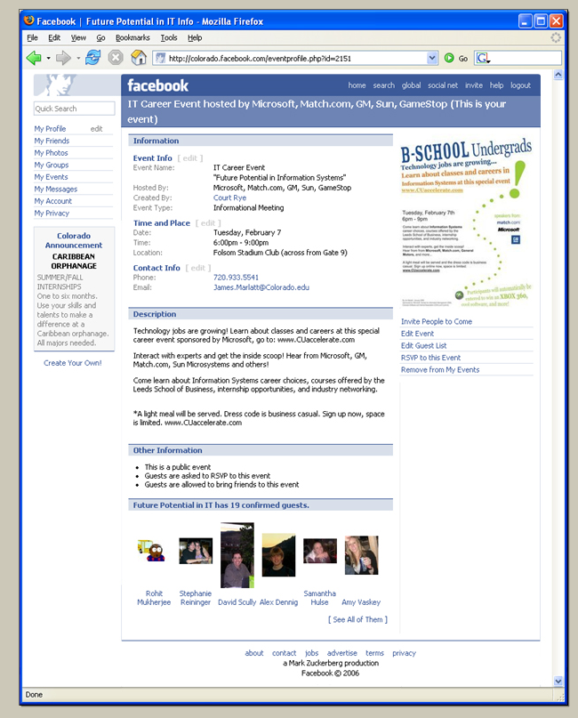

Appendix B – Press Release
Seminar at CU Boulder dispels myth about lack of jobs in IT
Future Potential in IT seminar connects business leaders, recent college graduates and fellow students with local scholars to encourage pursuing careers in IT

Boulder, Colo. – February 1, 2006 – College students may have heard that few jobs exist in information technology (IT) in the U.S., but a February 7 seminar at University of Colorado-Boulder will demonstrate just how wrong this myth is.

The Future Potential in IT seminar – co-hosted by Microsoft, the University of Colorado-Boulder, the Society for Information Management (SIM), Colorado Software and Internet Association (CSIA) and Culminis – will link senior IT executives and recent CU-Boulder graduates with current students to discuss the benefits of adding a technology focus to their career aspirations and encourage them to pursue a career in an IT-related field.

“IT is an exciting career option, and this program will show what’s available in this industry right here in Colorado and across the U.S.,” said Microsoft Regional Technology Officer Scott Johnson. “The future of IT has never been brighter, and we are committed to helping students find ways to take advantage of all these great opportunities. Through the Future Potential in IT seminar, students will have opportunities like never before to hear about the exciting and diverse opportunities in IT, from many interesting people working for different companies. Microsoft is proud to join the University of Colorado-Boulder, SIM, CSIA and Culminis to showcase what information technology has to offer students now and in the future.”

The Future Potential in IT seminar series is a national program designed to encourage undecided college freshman and sophomores – including women and students with diverse backgrounds – to consider a major in IT.

“We want to inspire and motivate our students to be more knowledgeable about IT, and what better way than by hearing from their peers and leaders in the field?” said Jim Marlatt, senior instructor at University of Colorado-Boulder’s Leeds School of Business. “We’re hoping this seminar will provide Colorado students – particularly those still charting their main career path – with the information to help them consider the possibilities of working in the field. The reality is no matter what we do, we are surrounded by technology. Our students must know how to use these tools, while also working to make them better.”

On February 7, the University of Colorado-Boulder will host its Future Potential in IT seminar at the Folsom Field Stadium Club, 372 UCB in Boulder. The event will begin at 6:00 p.m. with a complimentary light dinner from Microsoft, and the program will kick off at 6:30 p.m. with remarks from senior executives for Match.com, the National Center for Women and Information Technology and GMAC Capital Holdings. A panel of other local IT professionals and recent CU-Boulder graduates will also speak with students during a group discussion and Q&A, and Microsoft prizes will be raffled at the event’s end.

To find out more and to register, go to www.CUaccelerate.com.

About University of Colorado-Boulder
Founded in 1876, CU-Boulder offers 3,400 courses in about 150 fields of study to its more than 28,000 students. Recognized internationally as a top research institute, CU-Boulder received nearly $258 million in sponsored research awards for the 2005 fiscal year. In 2005, faculty member John Hall of JILA, a joint institute of CU-Boulder and the National Institute of Standards and Technology, became the fourth CU-Boulder faculty member to be awarded a Nobel Prize. For more information, please visit www.colorado.edu.

About Microsoft
Founded in 1975, Microsoft (NASDAQ “MSFT”) is the worldwide leader in software, services and Internet technologies for personal and business computing. The company offers a wide range of products and services designed to empower people through great software — any time, any place and on any device.

About the Society for Information Management (SIM)
Established in 1968, the Society for Information Management (SIM) is the premiere network for IT leaders comprised of nearly 3,000 members including CIOs, senior IT executives, prominent academicians, consultants, and other IT leaders. SIM is a community of thought leaders who share experiences and apply rich intellectual capital, and who explore future IT direction. Through its 30 chapters, SIM provides resources and programs inspired by IT leaders for IT leaders that enable CIOs to further develop the leadership capabilities of themselves and the key and emerging leaders in their organizations. SIM provides the collective voice to advocate policy and legislation on behalf of the IT profession across industries. For more information, please visit www.simnet.org.

About the Colorado Software and Internet Association (CSIA)
The mission of CSIA is to foster innovation and a positive growth environment to enable the technology industry in Colorado to compete on a global basis. CSIA is the voice of Colorado’s technology community, connecting member companies in their fields and building recognition of Colorado's IT industry as a global leader in technology development and application. The organization serves its more than 250 Colorado company members as well as the more than 3,000 IT companies in Colorado with connections, advocacy, and programming, as well as lobbying on behalf of the industry with state legislative and regulatory issues. For more information, please visit www.coloradosoftware.org.

About Culminis
Culminis is an international organization representing the culmination of ideas, aspirations and needs of information technology (IT) professionals. By building a partnership between IT pros and IT solution providers, Culminis strives to improve the skills, abilities and knowledge of our members along with the technologies they depend on – helping to elevate the status of IT professionals in the workplace as well as the community. For more information, please visit http://usa.culminis.com/.

Boulder Daily Camera
2/7/06
Jason Williams
CU tries to win back IT fervor
http://www.dailycamera.com/bdc/buffzone_news/article/0,1713,BDC_2448_4446222,00.html

A decade ago, one of the most exciting new career tracks for a college student was in information technology. Then the euphoria fizzled as the dot-com bubble burst.

But IT job openings appear to be on the rebound, according to experts in the field.

The result: a shortage of qualified candidates for Colorado technology jobs. Professors and local industry executives will attempt to combat this trend with a informational seminar today at the University of Colorado.

"The Future Potential in IT" program will attempt to dispel the myth that IT jobs are scarce, organizers say, and to encourage undecided students to consider an IT major — or consider adding a technical element to another major.
"We've seen the hiring really coming back in about the last 18 to 24 months," said Scott Johnson, Microsoft Corp.'s technology officer for the western United States. "We see a very healthy tech economy re-emerging, but it is one that is based much more on sound financial models and on market needs than on conjecture and speculation as it was in the late '90s."

Microsoft is co-sponsoring today's program at CU.

Local technology companies are growing increasingly concerned about the shortage of qualified candidates coming out of Colorado high schools and universities, Johnson said.

"It's hard to get an analyst job or a senior management job if you don't have some appreciation and understanding of the technology underneath," Johnson said.

Enrollment in IT degree programs at CU has fallen about 60 percent from its peak level in 2000, according to Ramiro Montealegre, chair of the systems division at the CU Leeds School of Business.

The trend at CU is reflected nationwide. The number of incoming students expressing interest in computer science also is down 60 percent, according to a survey last year by the Higher Education Research Institute at the University of California.
The prospects are looking up for current information systems majors. The diverse skills acquired in an IS degree uniquely qualify graduating students for high-paying jobs in a market projected to grow rapidly during the next six years, according to a report by the Occupational Information Network.

"Our students are receiving multiple offers. It hasn't been like that in a while," said James Marlatt, a senior instructor at the Leeds School. "It's an exciting time."

Marlatt started the effort to organize today's IT seminar.

For CU student Kate Dueber, the move toward an IS emphasis with her business degree has paid off. She was recently offered a job working for a technology risk consulting company.

"Because IT is such a wide field, there are so many things that you can do," Dueber said. She is participating in the seminar to encourage other students to consider a major in IS.

"I look forward to the fact that I am not going to be doing the same thing every day, because technology is always changing," Dueber said.

Sidebar
IF YOU GO

WHAT • "The Future of IT"

WHEN • 6 p.m. today

WHERE • Folsom Field Stadium Club

COST • CU students should bring BuffOne card to get in

INFO • www.cuaccelerate.com

ETC. • Business casual attire is recommended

Colorado Daily News
2/6/06
Matt Williams
Want a job?
http://www.coloradodaily.com/articles/2006/02/05/news/c_u_and_boulder/news1.txt

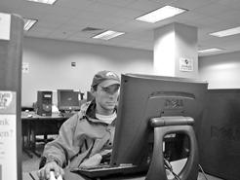
Want a job?
By MATT WILLIAMS Colorado Daily Staff Writer
Sunday, February 5, 2006 7:41 PM MST
When CU-Boulder senior Kate Dueber started looking for a job to complement her marketing and information systems majors, she wasn't sure what she'd find.
Like many students, Dueber had heard that jobs in information technology were scarce because of Colorado's economic downturn a few years ago.
“I think what I've been finding, along with my classmates, is that there really are more jobs in IT (information technology) than we were led to believe,” she said late last week, having recently accepted a job as a technology risk consultant.
The CU-Boulder Leeds School of Business is partnering with Microsoft, the Society for Information Management, the Colorado Software and Internet Association and Culminis to host an inaugural conference Tuesday bringing CU students and recent graduates in touch with senior-level executives from a few of the nation's top corporations.
The message: companies need more entry-level employees with skill sets in business and technology.
“We're not graduating enough people with math and science backgrounds, and engineering areas,” Microsoft Regional Technology Officer Scott Johnson told the Colorado Daily. “And I think that relates directly to we've got great IT jobs opening up, and we're not finding great Colorado candidates.”
Last week, Denver mayor John Hickenlooper announced the U.S. Dept. of Labor awarded the metro area a $15 million Workforce Innovation in Regional Economic Development (WIRED) grant to prepare workers living the region for high-tech jobs.
Information technology is a broad and constantly changing field, encompassing everything from data management in accounting to computer systems design, even coming up with ways to make a cell phone able to share data with a laptop.
The nature of IT has shifted so that a background in computer programming isn't a necessity anymore, Johnson said.
“In the last couple of years, we've seen a tremendous turnaround in hiring in the Colorado region, particularly in technology,” Johnson said. “This is everything from biosciences and pharmaceuticals, into IT and data-management related jobs.”
An analysis of U.S. Bureau of Labor Statistics by Richard Baskerville of Georgia State University reports that the unemployment rate in the United States at the end of 2005 was 4.9 percent, but only 1.9 percent for computer and math occupations.
The number of unemployed IT workers has declined by 135,000 since the beginning of 2004, according to Baskerville.
“One of the biggest concerns people have right now is that we won't have enough talent to fill the jobs that are being created,” said CU-Boulder business instructor Jim Marlatt
Registration remains open for the “The Future Potential in IT” seminar. (About 150 students have signed up so far.) For more information and to register, go to go to www.CUaccelerate.com. The event is 6 p.m. to 9 p.m. at the Folsom Field Stadium Club, 372 UCB in Boulder.
The evening begins with a free dinner from Microsoft, and the program will kick off at 6:30 p.m. with remarks from senior executives for Match.com, the National Center for Women and Information Technology and GMAC Capital Holdings.
Its one of 15 similar IT seminars Microsoft plans to sponsor in 2006.
The most important part of the event is networking with prospective employers, Marlatt said.
“I don't care if you're a finance major, an accounting major, an engineer or whatever - having some knowledge of this stuff is important,” he said.

